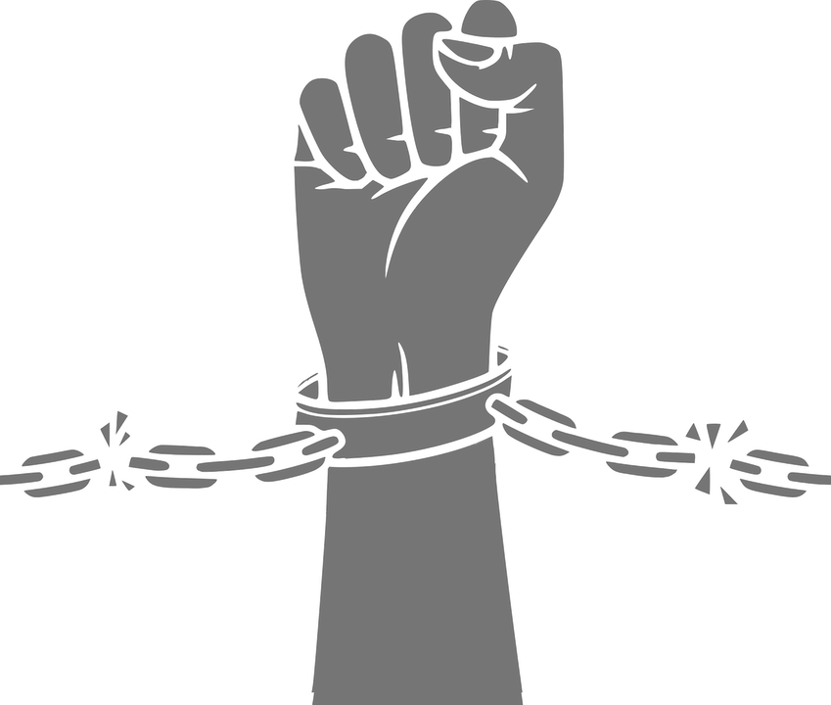 **Slavery: Corroborating Evidence **

|  |  |  |  |
| --- | --- | --- | --- |
|  | **What does the claim imply?** | **How does the evidence corroborate and/or contradict the claim? It can do both.** | **Why do you think the evidence contradicts the claim?**  **Only fill out this column with contradictory evidence.** |
| A |  |  |  |
| B |  |  |  |
| C |  |  |  |
| D |  |  |  |
| E |  |  |  |